**Introduction and Business Problem**

A customer and a friend named Ravi, wants to open a Fast Food Restaurant in Durham Region, Ontario, Canada. There are 8 municipalities in Durham Region and each being Diverse, it is hard to locate the best location to open a restaurant. As this is going to be his biggest investment, he is looking to have this restaurant closer to schools, colleges and universities, looking to attract maximum customers.

Hence, we need to choose the best locality that has plenty of customers and least amount of competition.

**Data**

**To help Ravi in his search we will need to access following data:**

* The municipalities/localities of Durham Region, Ontario, Canada from Wikipedia:

<https://en.wikipedia.org/wiki/Regional_Municipality_of_Durham>

* The coordinates (latitude, longitude) of these Localities of Durham Region from Open Street Map APIs

**From Foursquare we will need following venues data:**

* Fast food venues of the Localities
* High Schools venues of the Localities
* Universities venues of the Localities
* Offices venues of the Localities
* Shopping Mall venues of the Localities

We will then leverage the data to determine which locality is the most suitable to open a Fast Food Restaurant in Durham Region.

**Methodology**

For each locality, all offices, schools, universities and Fast Food restaurant venues data have been collected from Foursquare. Then for each locality, the sums of the office, school, university and burger joints were computed.

**For each of these categories, a weight (or penalty) has been defined accordingly to what Ravi considers most important.**

* Fast Food Restaurants have been weighted with -1, since Ravi wants to avoid concurrence.
* Shopping Malls have been weighted with 1, since Shoppers mostly buy food from inside the mall but still considered good customers.
* Schools have been weighted with 2, since student are good customers.
* Universities have been weighted with 2, since students are good customers.
* Offices have been weighted with 3, since employees are even better customers.

Note that the weights can be modified according to the importance of each category.

Lastly, a score was computed for each locality as the weighted sum of the number of venues in each of the 5 categories (school, university, office, fast food restaurants, Shopping Malls).

**Localities of Durham Region, Ontario, Canada**

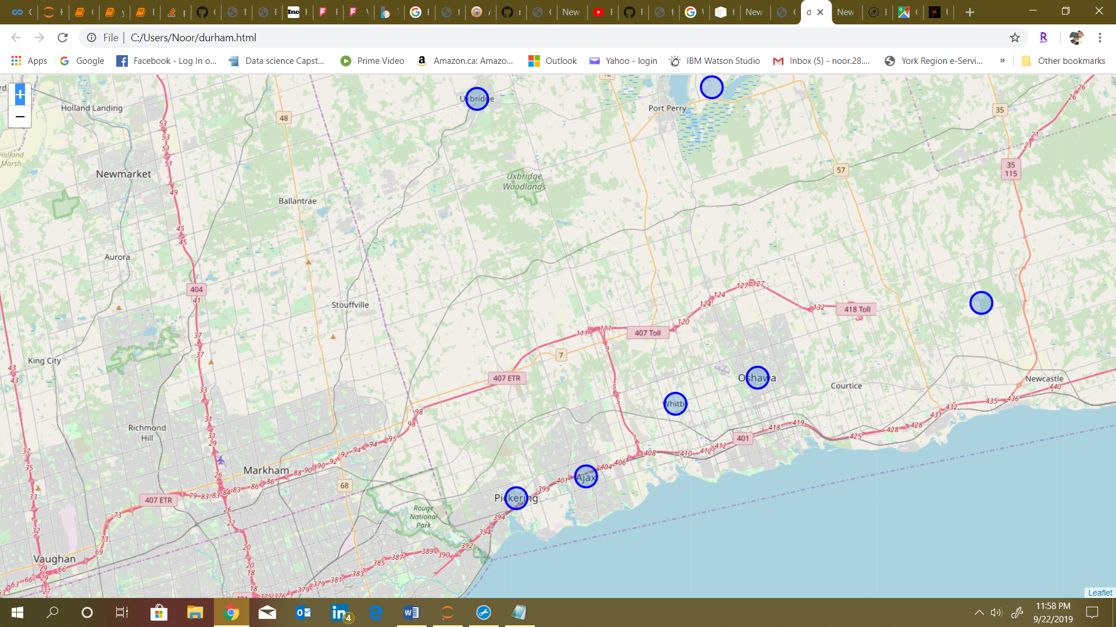

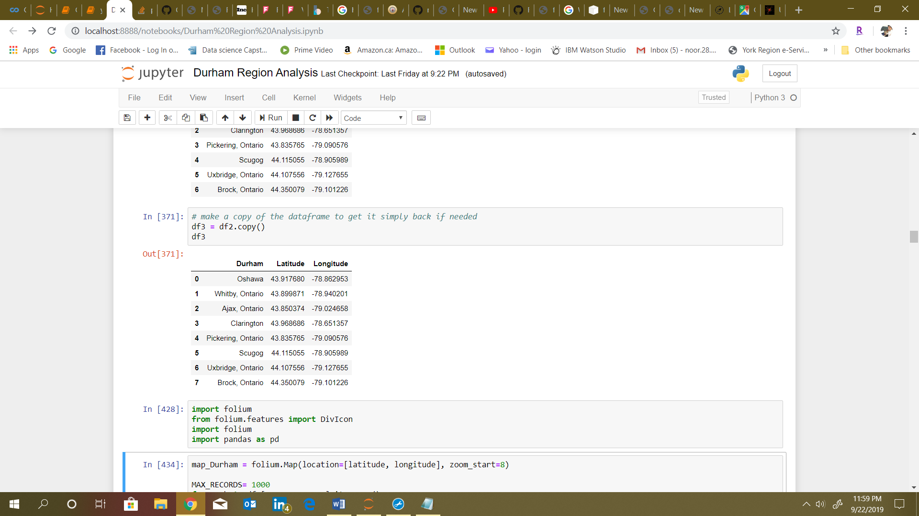

**Fast Food Restaurants in Durham Region** 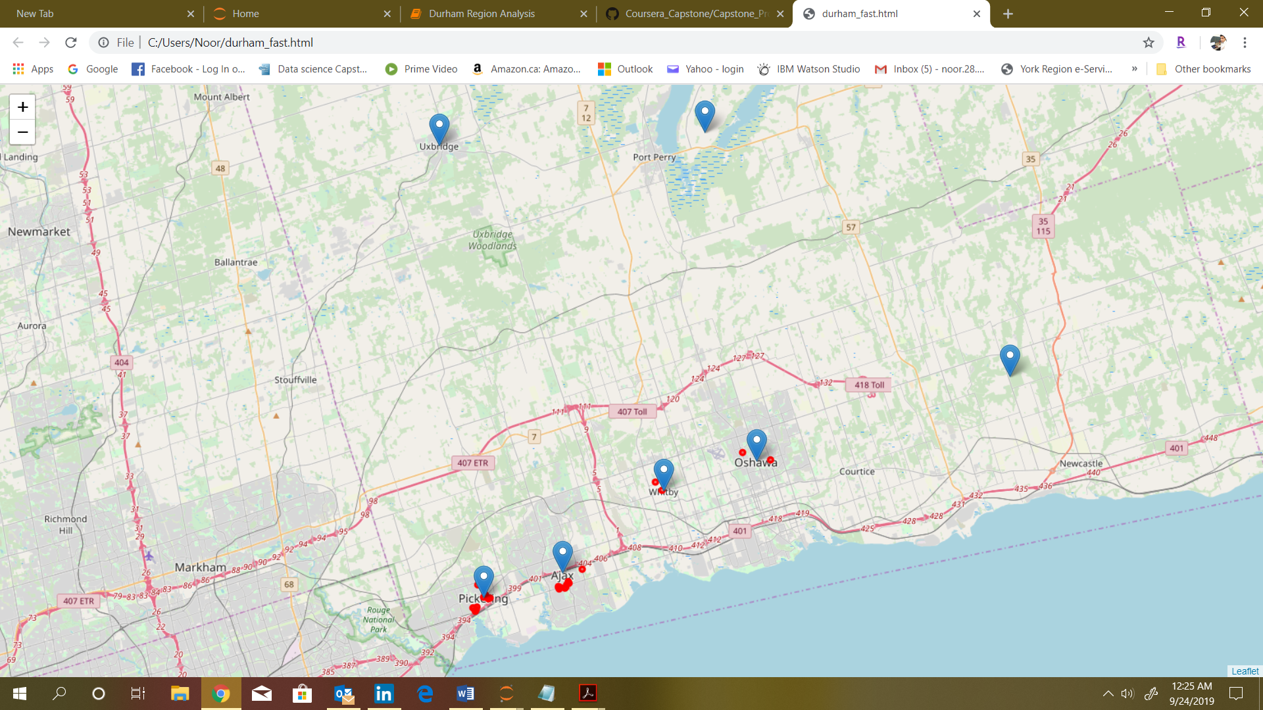

**High Schools in Durham Region** 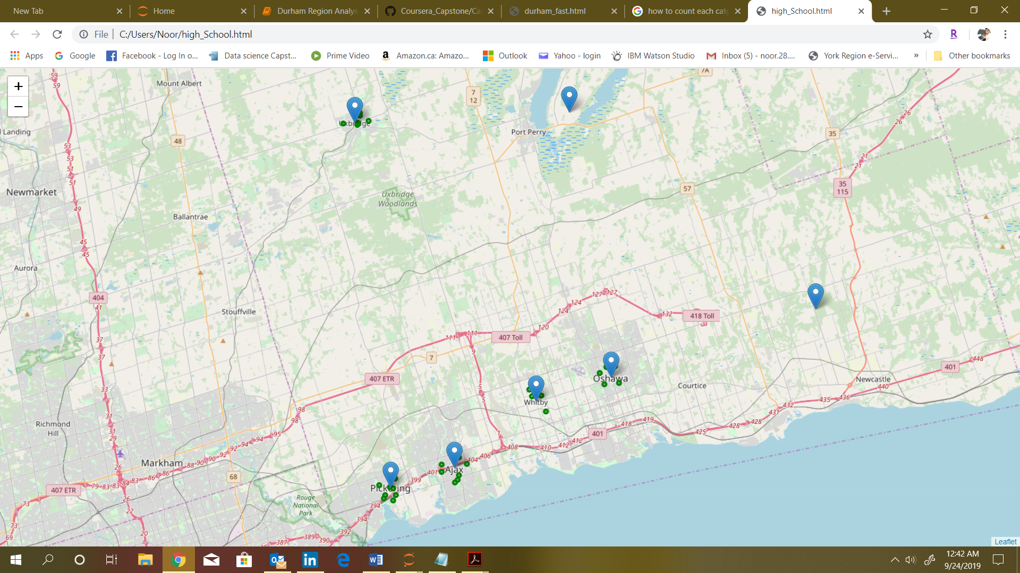

**Colleges in Durham Region** 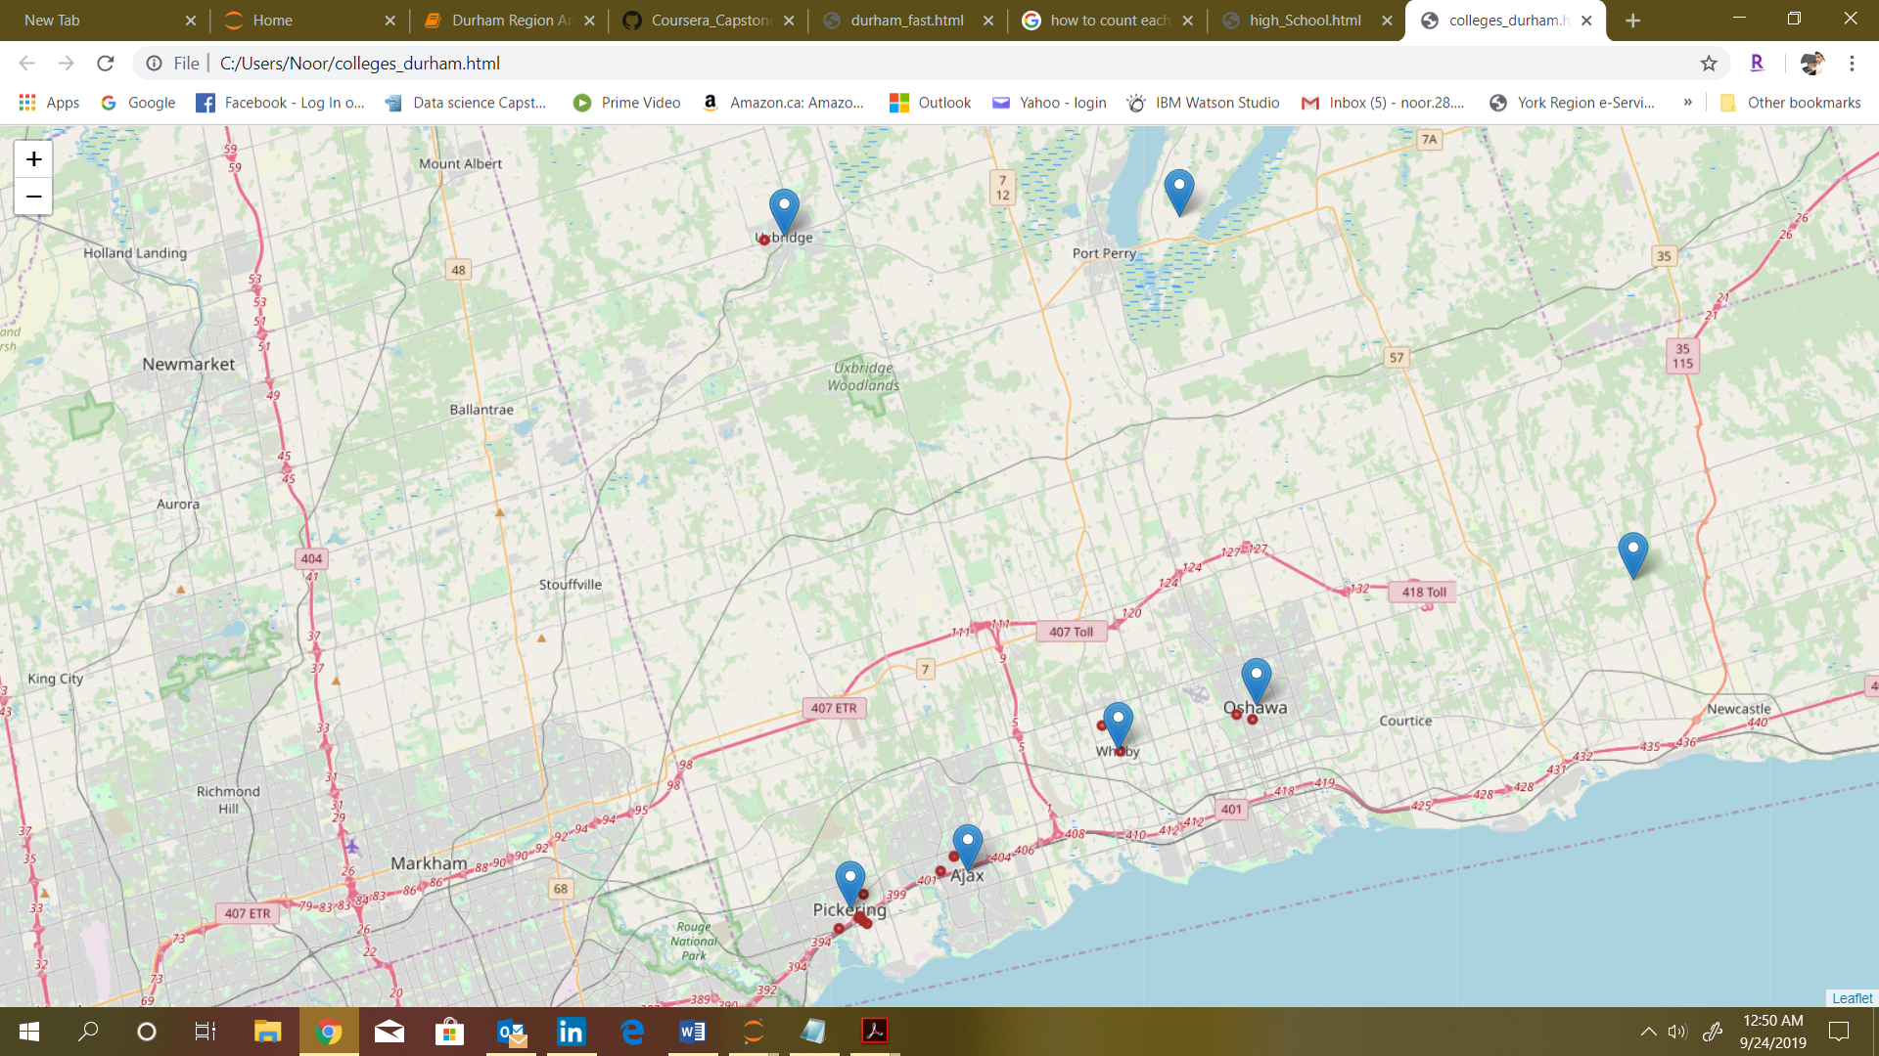

**Businesses in Durham Region**  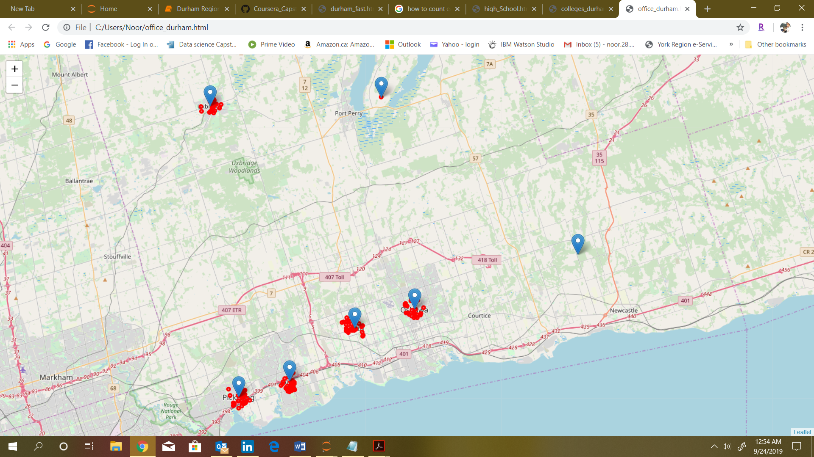

**Shopping Malls in Durham Region** 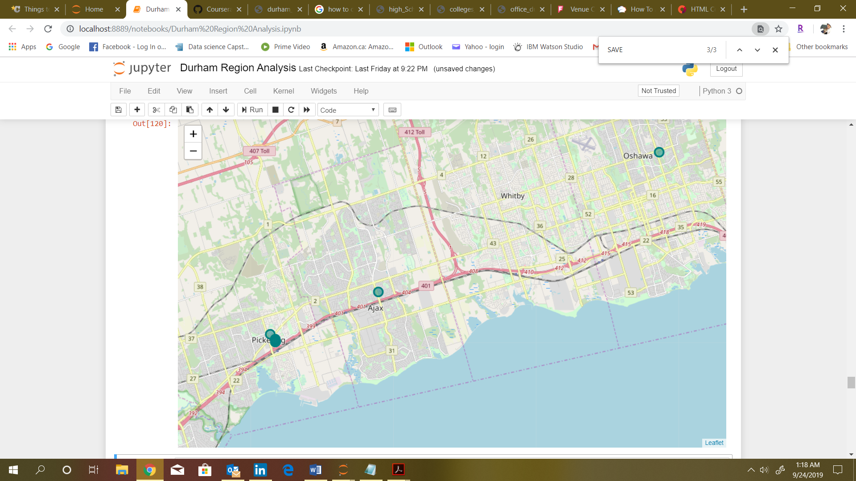

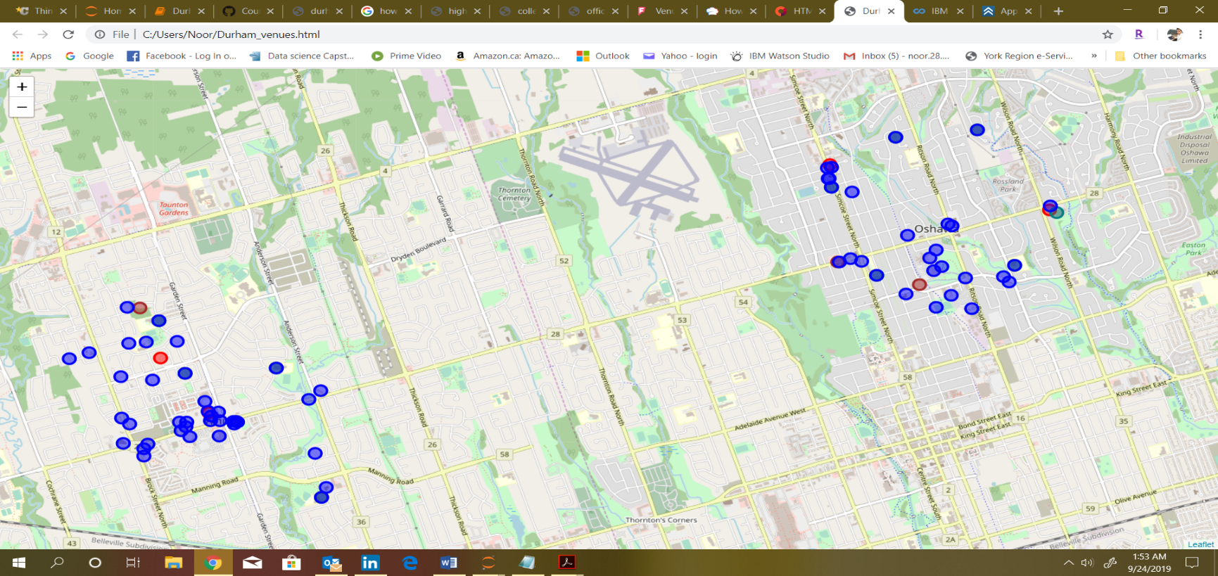**All of the Venues in Durham Region Donated By Color Coded Circles** 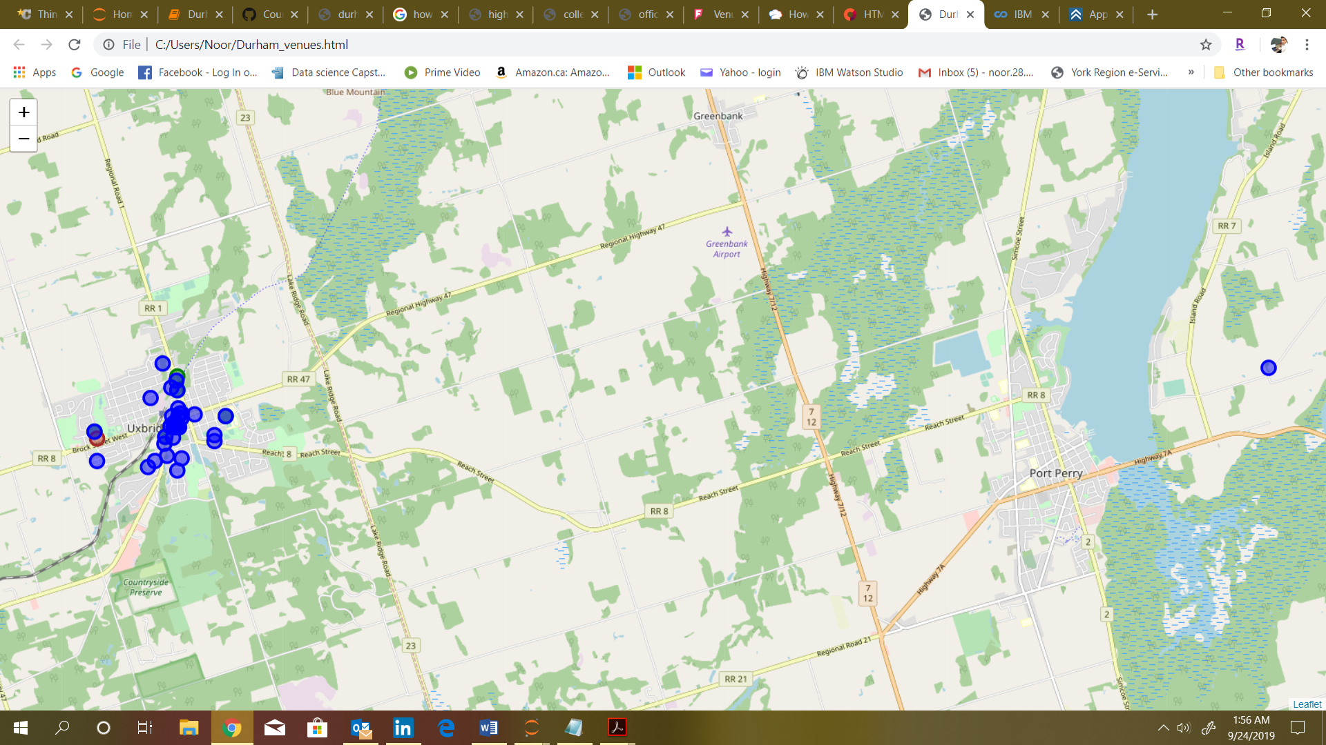

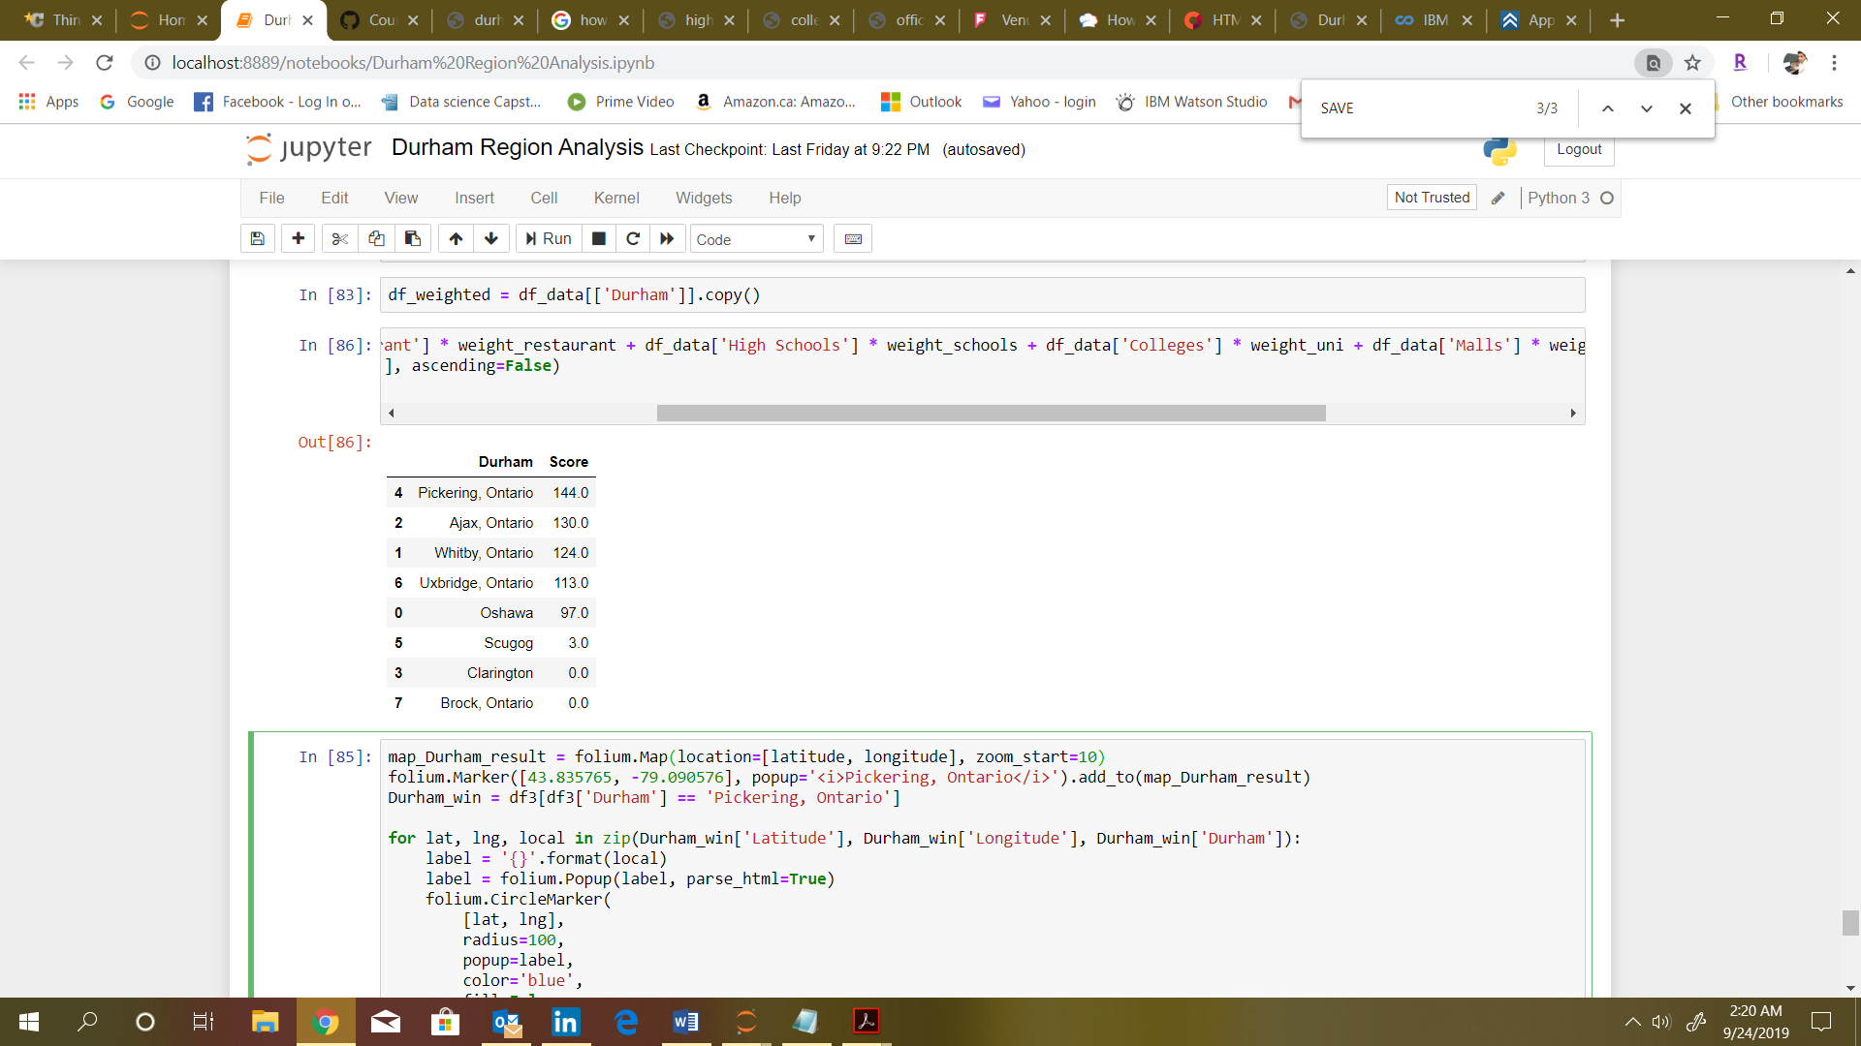

**Pickering, Ontario**

**Pickering, Ontario shows the best Locality to Open Fast Food restaurant in Durham Region with the Score of 144.**

**Next best comes Ajax, Ontario with close lagging to the Score of 130.**

**These Localities has maximum number of potential customers to attract from schools, universities, Businesses etc. and at the same time has not much competence.**

**Results**

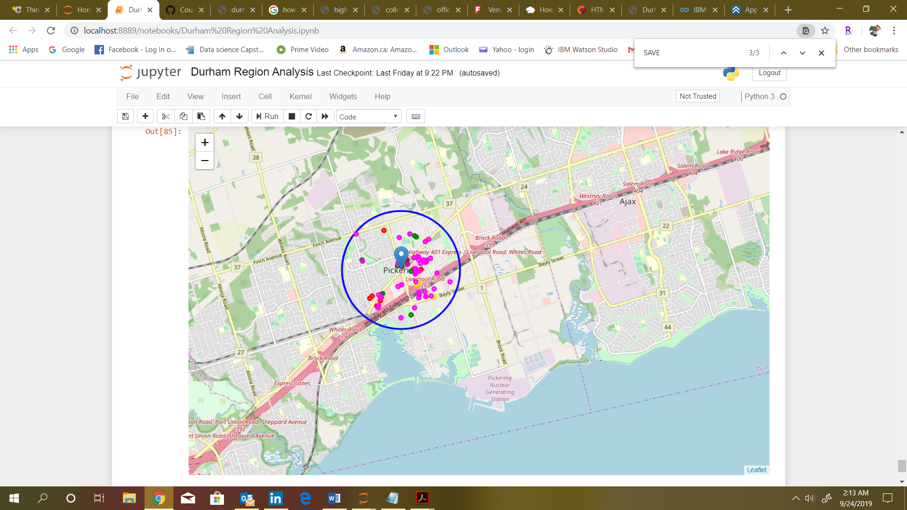Best Location to Open a **Fast Food Restaurant** in **Durham Region** is **Pickering Ontario.** Map of the Municipality showing all the Venues located withing the Locality and why this makes this City a preffered location than others.

*The analysis can be improved with following recommendations:*

* *Consider more categories or Venues like "Night life" which is also a good source to seek customers or "Restaurants", even not just fast-food which may be some concurrence.*
* *In the Locality itself, it can also be computed the distance between all the venues in order to find a place with the most number of potential customers.*
* *Using smaller geographical areas like Neighborhoods could also improve the accuracy for the scores.*

**Recommendation**